**Ideation Phase**

**Define the Problem Statements**

|  |  |
| --- | --- |
| Date | 19 September 2022 |
| Team ID | PNT2022TMID12805 |
| Project Name | Personal Assistance for Seniors Who Are Self-Reliant |
| Maximum Marks | 2 Marks |

**Problem Statement:**

To develop an IoT application that helps senior citizens to take the correct medication on time.   
There can be no replacement for a personal caretaker or Family member who takes care of elderly people. This IoT application can reduce the work of the caretaker or the family member to a minimum.

**Customer Problem Statement:**

Person 1:

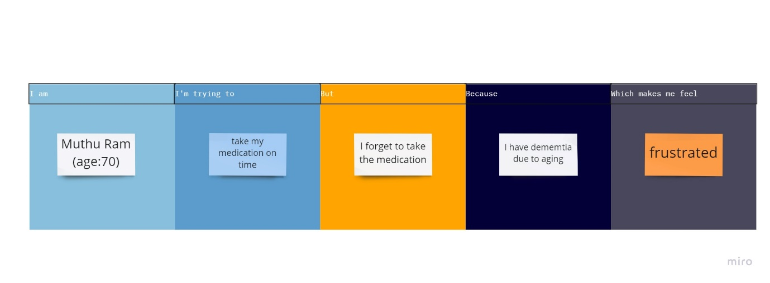

Person 2:

